**General Guidelines**

1. **Project Criteria**

* Your project name should be “**PC_[XXX]**”, where **XXX** is your **Province** **Name**.
* You need to submit the whole project folder.
* Make sure that your project can be run outside of your PC environment.
* Failing to do above items may result no mark given for Desktop Module.

1. **Database**

* You are not allowed to change database structure (table, column).
* You are allowed to add additional rows, however initial database will be used as marking.
* All delete process should be done using ‘soft delete’ concept, which is “an operation in which a flag is used to mark data as unusable, without erasing the data itself from the database”. In this case the flag is ‘deleted_at’ column. Pay attention to your select statement.

1. **User Interface Design**

* You may change certain components if it does not violate the business process requirement. If possible, it is recommended to stick to the given design.
* No additional bonus given to over excessive design (feature > design).

1. **Form**

* The MDI Form usage is a must.
* When opening a new form, the form should be positioned in the center of the screen.
* A form that is opened from another form, should be used as Dialog Form. It means that the focus is the last open form.
* By default, most components that used to display data only must be set to ‘read-only’.
* Pay attention to which component that should be editable or not.

1. **Validation**

* You must add validation for every input process.
* Use your judgement to decide what kind of validation is required. This is part of the analytic marking criteria. If a specific validation is requested, then it will be mentioned in the documentation.

**Hov Library Management System**

This time you are given task to develop a desktop application using C# Programming Language and .NET Framework for Hov Library. The specific features are explained below.

1. **Login Form**

* This form is used by Employee to login to the applications.
* They can use email and password as login credentials.
* The password is stored in the form of SHA256 hashed value.
* Give proper message if the login process is fail. If the login is success, redirects user to Main Form.

Figure . Form Login

1. **Main Form**

* This is an MDI Form which will contains other form.
* The form must be started in fully maximized state.
* Only one form of the same type allowed to exist every single time.
* There are three menus: Master (Member, Book), Borrowing (New Borrowing, All Borrowing), and Logout.
* Logout menu can be used to close the MDI form then redirects to Login Form.

Figure . Main Form (MDI)

1. **Master Member**

* This form shows all registered member at Hov Library.
* When a row is selected, display its detail in each respected component.
* When edit button is clicked, every component will be available to edit the selected record. Save Changes button will be clickable, and on click it will update the selected record. Make sure to give proper validation for each field.

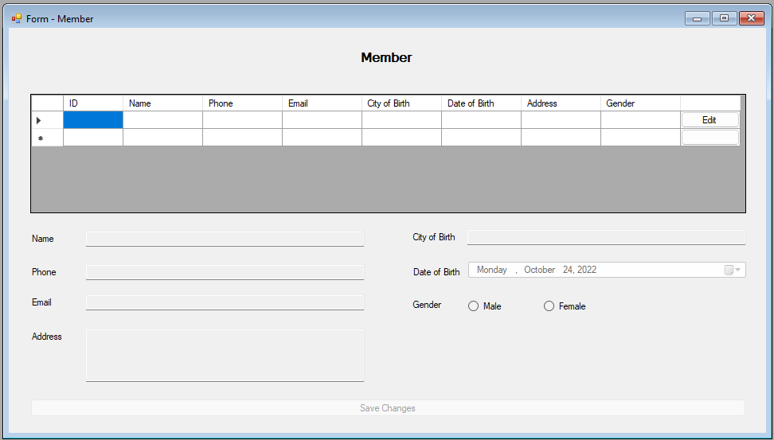

Figure . Master Member

1. **Master Book**

* This form shows all available books title in Hov Library.
* When a row is selected, display its detail in each respected component.
* You can search the book (using ‘LIKE’ query) by title, author or publisher, the choice can be made by changing the dropdown value.
* You can filter the book data shown based on language, publish date, page count, and ratings.
* When edit button is clicked, every component will be available to edit the selected record. Save Changes button will be clickable, and on click it will update the selected record. Make sure to give proper validation for each field.
* When delete button is clicked, show a confirmation dialog whether to delete the record or not.
* When show button is clicked, Form Book List will be shown for the selected record.

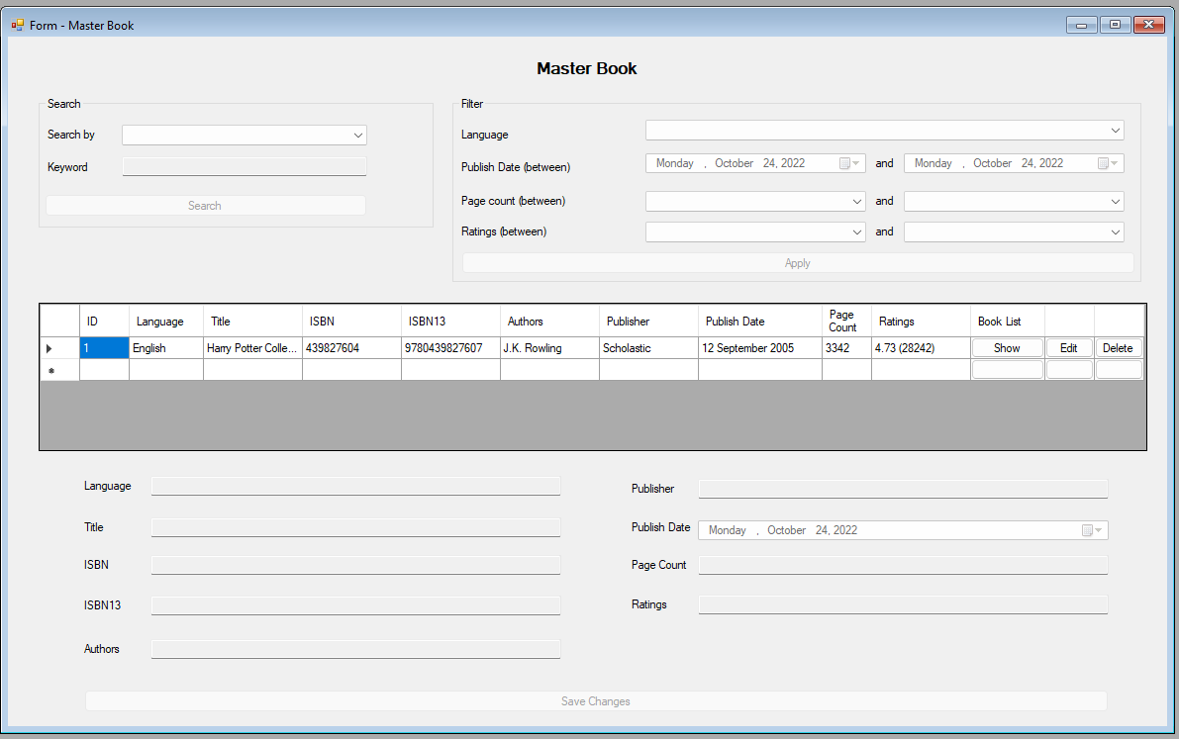

Figure . Master Book

1. **Form Book List**

* This form will be used to show all available books for the selected title from the Master Book Form.
* Display the book title, and all books of the selected title.
* The book status would be unavailable (if it’s currently borrowed) or available.
* When delete button is clicked, show a confirmation dialog whether to delete the record or not. Only available book can be deleted.
* New book can be added by first selecting the store location. On change, the book code will be automatically generated with the following pattern:

$$AAAA.BBBB.CC.DDDD$$

Where AAAA is bookdetails_id, BBBB is book_id, CC is location_id, and DDDD is the year when that title is published.

* After success insert, the data will be added to the list.

Figure . Form Book List

1. **Form Add New Borrowing**

* This dialog form can be used to add new borrowing data.
* Book can be search based on its title using the AutoComplete feature. Display only available book to borrow for the selected title. There is a checkbox that indicates the selected book will be processed to borrow.
* Member can be search by its name using the AutoComplete feature. Clicking submit will registered the selected book as borrowed by the selected member.

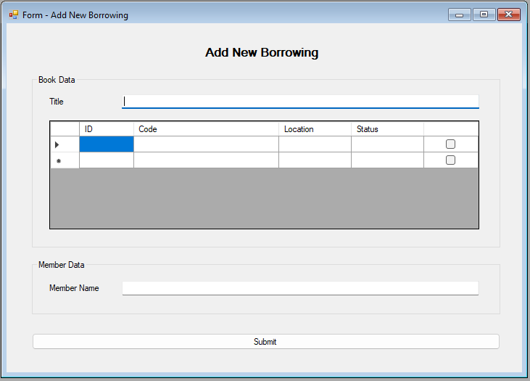

Figure . Form Add New Borrowing

1. **Form All Borrowing**

* This form will be used to show all borrowing data.
* The data can be filtered based on their status, which is: Ongoing, Late (have not been returned after 7 days of the borrow date), and Returned.
* The data can also be filtered based on the borrowing date.
* Button return will be shown for each record that has Ongoing or Late status. Clicking this button, will initiate return process of the selected book. The application will calculate whether the borrow status is late or not. The fine will be calculated using the following formula:
$$\left(borrow_{date}- return_{date}\right)*1000$$

* After that, update the selected record of its status.

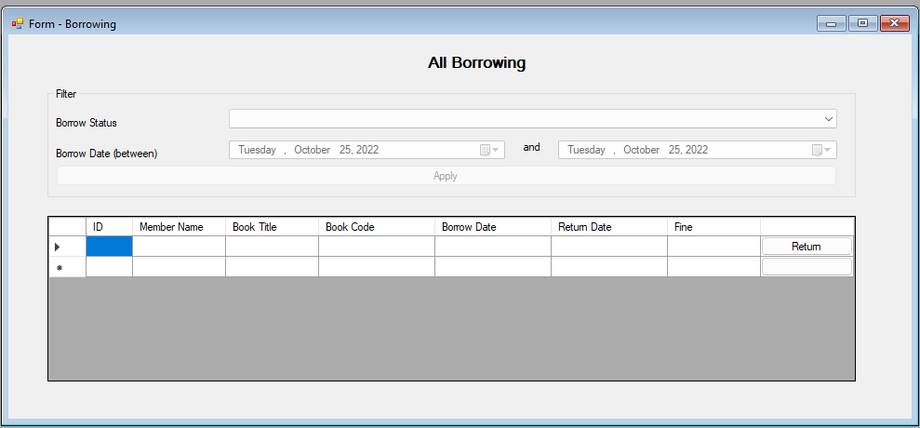

Figure . Form Meeting

**“Talk is cheap. Show me the code.” ― Linus Torvalds**